Homepage / PIU functions and dashboard / Notifications received by the PIU
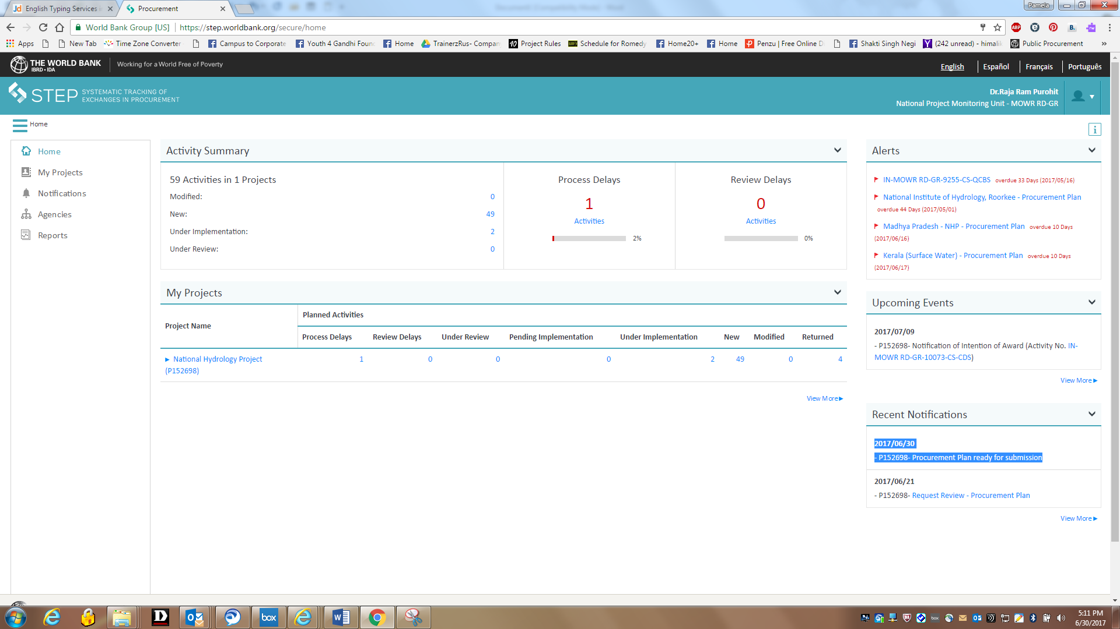

Access Communication log after clicking notification - Shows agency highlighted in the left hand corner.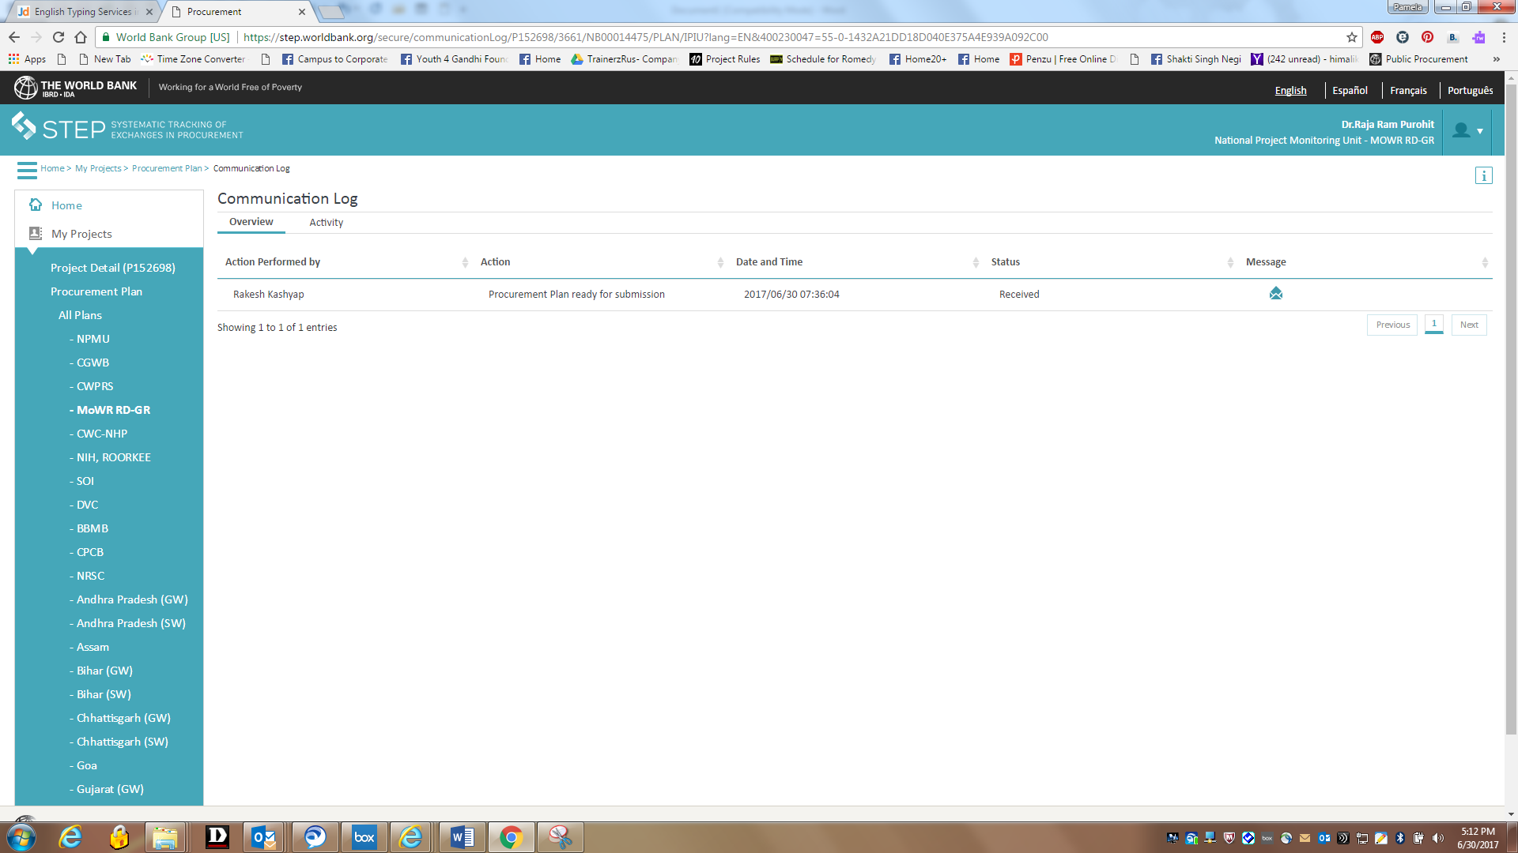

Adding activities – Procurement plan
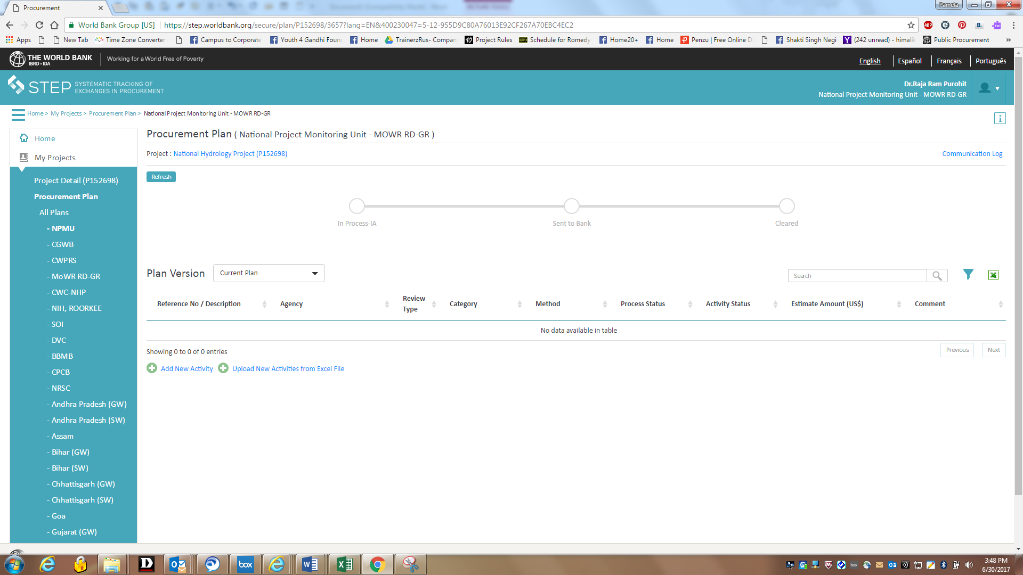

Click on “Inform PIU” button – after adding all activities, the implementing agencies will inform PIU by clicking this button / IA can edit the plan if the plan is pending with PIU / but if plan pending with Bank then no edits can be made on PP.
Then PIU will send the PP to Bank for clearance using the - Send to Bank button (2 activities cleared and 1 activity pending)
Any edit which you make to the Procurement plan will come to the Bank for approval
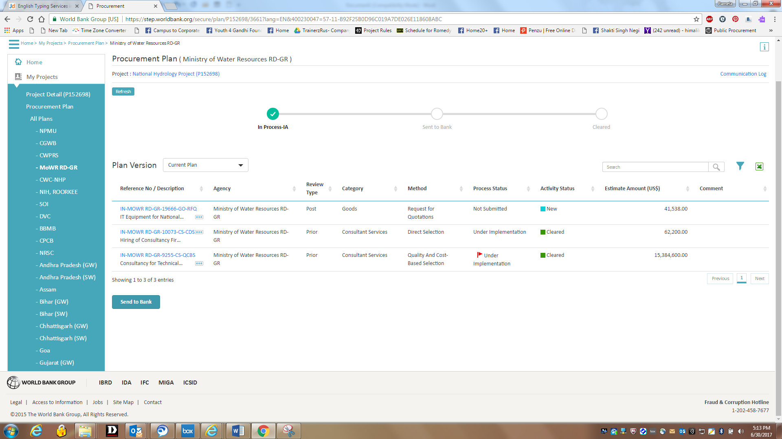

All activities NOT cleared in this plan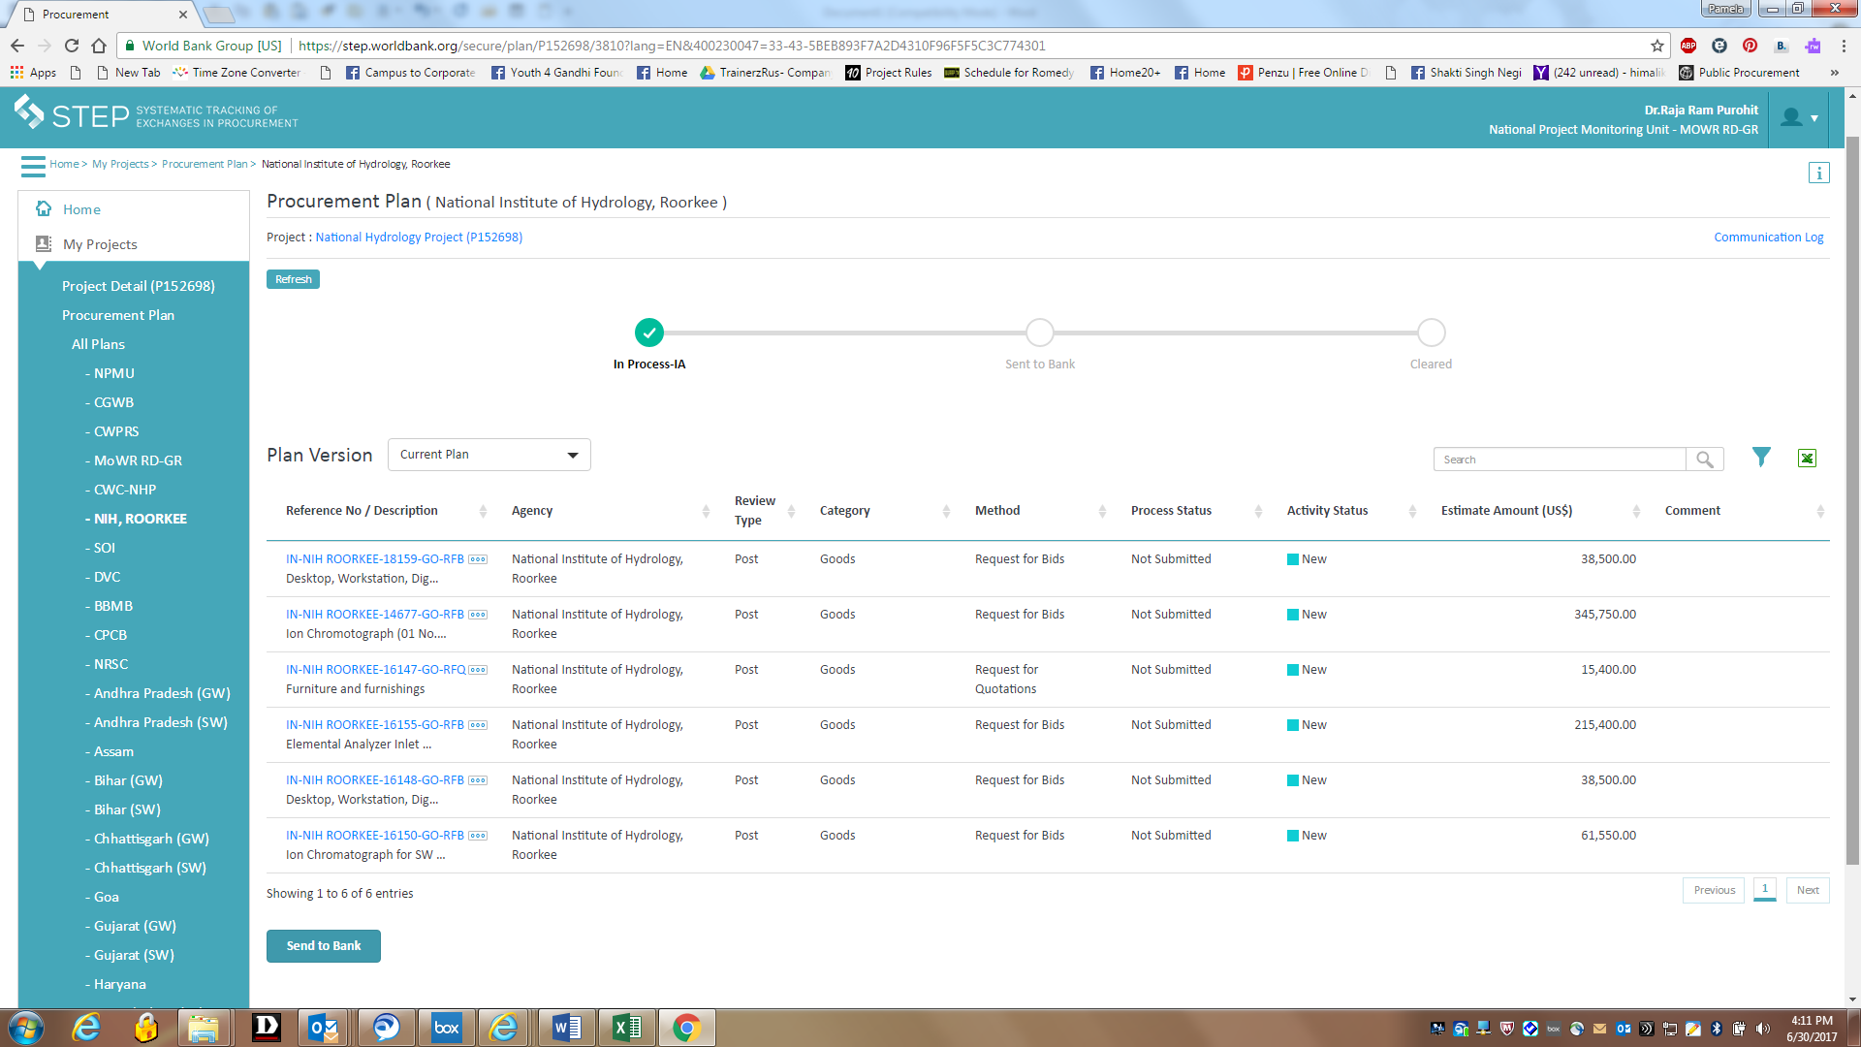

Already sent to bank – Under Review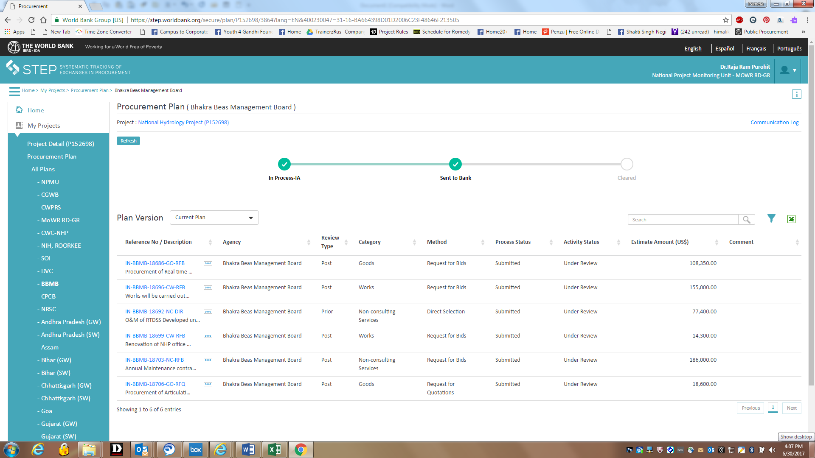

BAFO not to be selected
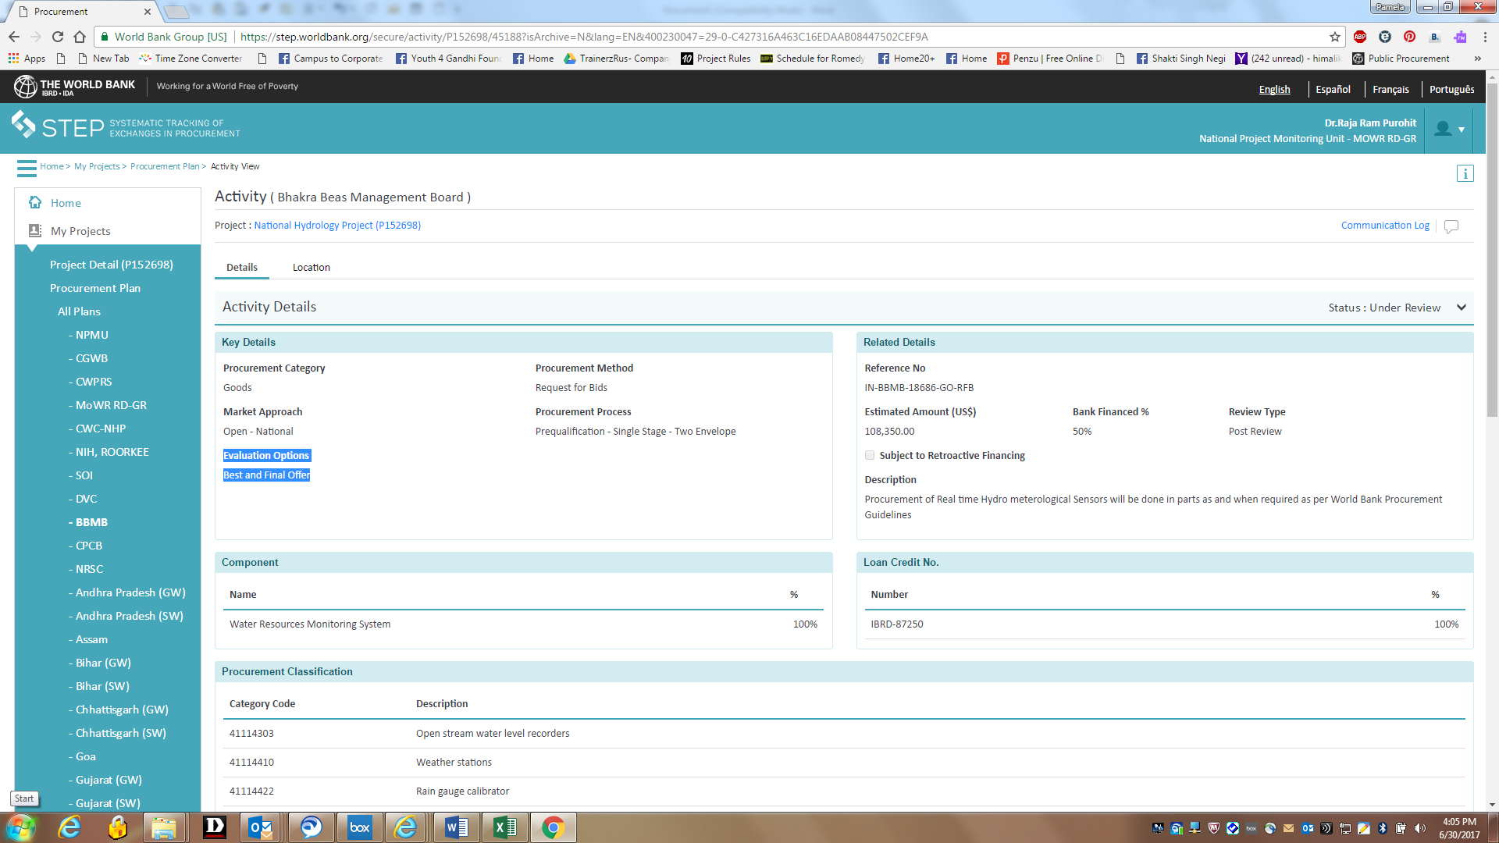

Cleared by the Bank
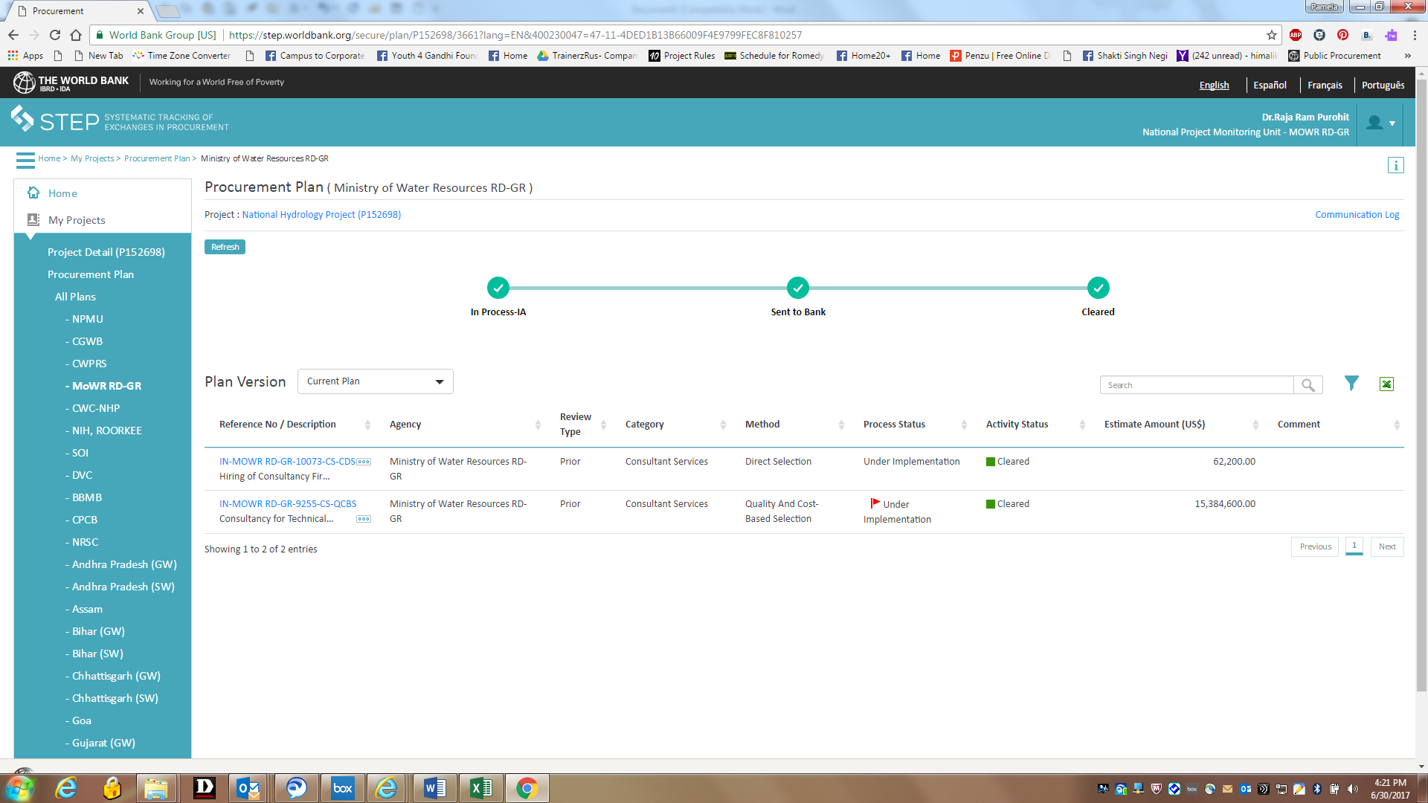

Roadmap: to complete all steps one by one / not to skip as in this example

